The Saracens Head

Daily lunch Menu
-Tuesday 18th March -

Starters

Curried Cauliflower soup, Netherend Farm butter, crusty bread - £9.50 (V)
Deep fried brie, Lemon gel - £10 (V)
Whitebait, curry mayonnaise - £10
BBQ Chicken, cheese potato skin -£10

MAINS
Pan fried gnocchi, button mushrooms, leeks, spinach, parmesan sauce(V) - £19
Beer battered haddock, chips, mushy peas, tartare sauce (GF*) - £21
Mushroom and onion burger, Monterey jack cheese, sourdough bun, chips, coleslaw (V)(VE*) - £19
Double Smash Burger, Monterey jack cheese, sourdough bun, chips, coleslaw - £19.5
Sweet potato, spinach and chickpea curry, coconut rice, onion bhajis (VE*)(GF*) -£19.5
Beef Lasagne, garlic bread, salad - £19.50
Gammon, chips, peas, eggs - £20
Pan seared Seabass, potato rosti, creamed leeks -£23
Venison Faggots, mashed potatoes, seasonal greens, jus - £20
BBQ pulled pork burger, Monterey jack cheese, sourdough bun, chips, salad (GF*) - £19.5

Sides

Chips £4.5
Garlic Bread £4
Cheesy Garlic Bread £5
Peppercorn Sauce £4.5
Seasonal Greens £4.5

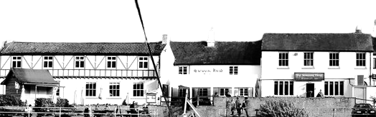

Children’s £10.75

Battered Haddock, chips, mushy peas
Mushroom burger, chips (V)(VE*)
Smash burger, chips
Beef lasagne, garlic bread

The Saracens Head

Daily lunch Menu
- Tuesday 18th March -

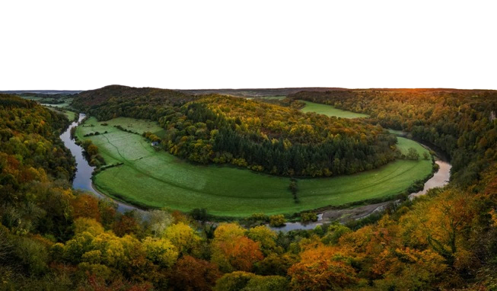
*These dishes can be made gluten free or vegan. Please ask your server if you would prefer this option.
While every care is taken with allergens in our meals, we operate a busy, single room kitchen and cannot 100% guarantee any dish is free of allergens.
For tables of 10 or more a voluntary 10% service charge will be added to your bill. 100% of tips go to our team members
ICE Creams

1 Scoop £2.5/2 scoops £4.9/3 Scoops £6

Vanilla
Chocolate
Alphonso Mango Sorbet
Cherry Cola Sorbet
Passionfruit Sorbet

DESSerts £8.50

Chocolate brownie, hot chocolate fudge sauce, vanilla ice cream
Apple, blackberry and cinnamon crumble tart, vanilla ice cream
Treacle tart, vanilla ice cream
Raspberry Bakewell tart, vanilla ice cream

