The Saracens Head

Daily LUNCH Menu
- Friday 6th June -

Starters

Leek and Potato soup, Netherend Farm butter, crusty bread (V) - £9.50
Deep fried brie, red onion chutney (V) - £10
Cajun fried calamari, wild garlic mayonnaise - £10
Pork and miso arancini, apple ketchup - £10
Truffle infused rarebit on wholegrain bloomer - £10

MAINS
Pan fried gnocchi, button mushrooms, spinach, creamy parmesan sauce (V) - £20
Mushroom burger, Monterey jack cheese, burger sauce, sourdough bun, chips, coleslaw (V) - £20
Beer battered haddock, chips, mushy peas, tartare sauce - £22
Double smash burger, Monterey jack cheese, sourdough bun, burger sauce, chips, coleslaw - £21
Welsh dragon sausages, mashed potato, seasonal greens - £21
Pan fried seabass, saluted new potatoes, peas a la francaise - £23
Gammon, garden peas, fried eggs, chips - £20
BBQ pork burger, Monterey jack cheese, sourdough bun, burger sauce, chips, coleslaw - £21
Sweet potato, spinach and chickpea curry, coconut rice, onion bhajis (VE*)(V) - £20.50
Pork, mushroom and spinach vincigrassi, garlic bread, salad - £20
9oz Welsh ribeye – confit mushrooms, slow roasted tomato, chips - £36
Hunters chicken, bacon, cheddar cheese, BBQ sauce, chips, salad - £21
Saracens lamb donner, chips, flatbread, salad, chilli sauce, garlic sauce - £20
Linguine Bolognese - £20

Sides

Chips £4.5
Garlic Bread £4.5
Cheesy Garlic Bread £5.5
Seasonal Greens £4.5
Peppercorn sauce £4.5

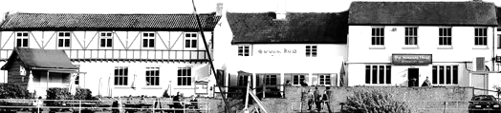

Children’s £11

Smash cheeseburger, chips
Haddock, chips and mushy peas
Mushroom burger, chips

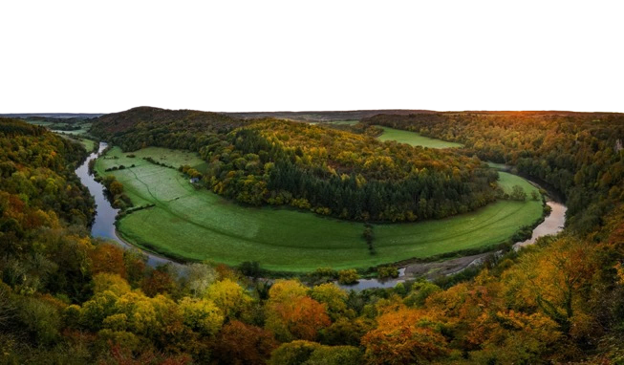

The Saracens Head

Daily LUNCH Menu
- Friday 6th June -

FERRYMAN’S LUNCH - £16.50

Served with salad, onion chutney, gherkins, pickled onion and white or brown crusty roll.

Cheese
Cheddar, Brie, Stilton

Ham
Honey roasted ham and cheddar

SANDWICHES

Served in a choice of white or brown bread/baguette with a side salad and salted crisps

Bacon, brie and cranberry - £13
Tuna mayonnaise - £12.50
Chicken, bacon and mayonnaise - £13
Cheese and pickle - £12

Honey roasted ham -£13
DESSERTS - £9

Chocolate brownie, hot chocolate fudge sauce, vanilla ice cream
Pear and almond frangipane tart, pear gel, vanilla ice cream
Lemon posset, shortbread, berry compote
Spiced apple pie, pouring cream

ICE Creams

1 Scoop £2.5/2 scoops £4.9/3 Scoops £6

Vanilla
Chocolate
Raspberry sorbet
Green apple sorbet
Orange sorbet

*These dishes can be made gluten free or vegan. Please ask your server if you would prefer this option.
While every care is taken with allergens in our meals, we operate a busy, single room kitchen and cannot 100% guarantee any dish is free of allergens.
For tables of 10 or more a voluntary 10% service charge will be added to your bill. 100% of tips go to our team members

