The Saracens Head

Daily dinner Menu
- Saturday 5th July -

Starters

Vegetable soup, Netherend Farm butter, stone baked baguette (V)(VE*) - £9.50
Deep fried brie, red onion chutney (V) - £10
BBQ chicken wings, salad - £11
Cajun fried calamari, garlic mayonnaise - £10
Greek salad, feta cheese, oregano dressing - £10
Caesar salad, parmesan - £10

MAINS (SERVED FROM 18:00-20:00)

Pan fried gnocchi, button mushrooms, spinach, creamy parmesan sauce (V) - £20
Mushroom burger, Monterey jack cheese, burger sauce, sourdough bun, chips, coleslaw (V) - £20
Beer battered haddock, hand cut chunky chips, mushy peas, tartare sauce - £22
Double smash burger, Monterey jack cheese, sourdough bun, burger sauce, chips, coleslaw - £22
Sweet potato, spinach and chickpea curry, coconut rice, onion bhajis (VE*)(V) - £21
Gammon, garden peas, fried eggs, chips - £22
9oz Welsh ribeye, confit mushrooms, slow roasted tomato, chips - £36
Beef stroganoff, mushrooms, gherkins, wild rice - £22
Welsh dragon sausages, mashed potato, red cabbage and jus - £21
Saracens lamb donner, chips, flatbread, salad, chilli sauce, garlic mayo sauce - £20
Pan fried seabass, sauteed new potatoes, peas a la francaise - £24
Pan fried megrim sole, romesco sauce, giant couscous and chickpea salad - £24
Pan fried seabass, sauteed potatoes, peas a la francaise - £24

Sides

Chips £4.5
Garlic Bread £4.5
Cheesy Garlic Bread £5.5
Seasonal Greens £4.5
Peppercorn Sauce £4.5
Stilton Sauce £4.5

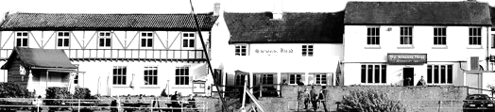

Children’s £11

Smash cheeseburger, chips
Haddock, chips and mushy peas
Mushroom burger, chips (V)(VE*)

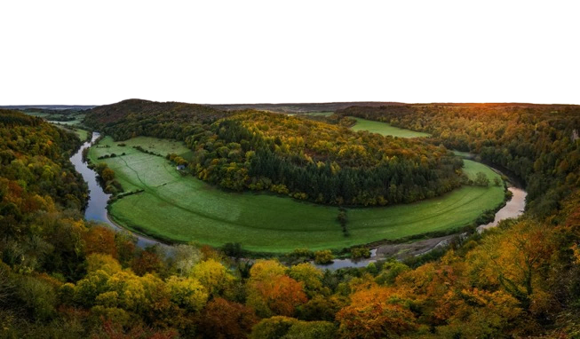

The Saracens Head

DAILY DINNER MENU
- Saturday 5th July -


(VE*) These dishes can be made vegan. Please let your server know of any allergies or dietary requirements.
Many of our dishes can be made gluten-free, please ask your server for details.
While every care is taken with allergens in our meals, we operate a busy, single room kitchen and cannot 100% guarantee any dish is free of allergens.
For tables of 10 or more a voluntary 10% service charge will be added to your bill. 100% of tips go to our team members.

DESSERTS - £9

Lemon butter biscuit posset, shortbread, berry compote
Spiced apple pie, vanilla ice cream
Sticky toffee pudding, vanilla ice cream
Gluten Free Brownie, vanilla ice cream
Blueberry clafoutis, pouring cream

ICE Creams

1 Scoop £2.5/2 scoops £4.9/3 Scoops £6

Vanilla
Chocolate
Raspberry sorbet
Green apple sorbet
Orange sorbet

